Writing
Task 1
You should spend about 20 minutes on this task.
The graph below gives information from Annual Energy Outlook 2008 about consumption of energy in the USA since 1980 with projection until 2030.
Summarize the information by selecting and reporting the main features, and make comparisons where relevant.
Write at least 150 words.
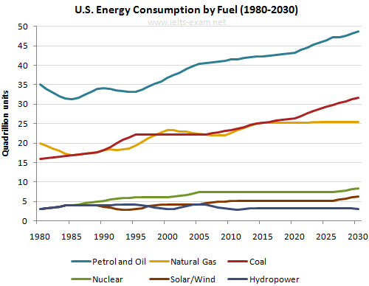

Task 2
You should spend about 20 minutes on this task.
Nowadays we see an increase in social problems involving teenagers. Many people believe that it is because parents spend more time at work and less with their children. Do you agree or disagree?
Write at least 250 words
Writing
Task 1
You should spend about 20 minutes on this task.

You have been to a business meeting at another company and saw a piece of equipment which can be useful for your company too.
Write a letter to your manager. In your letter:

- describe the piece of equipment you have seen
- why having the same equipment would be useful for your company
- offer your assistance in buying the equipment
Write at least 150 words.
You do NOT need to write any addresses.
Begin your letter as follows:
Dear Sir or Madam,

Task 2
You should spend about 20 minutes on this task.
Nowadays we see an increase in social problems involving teenagers. Many people believe that it is because parents spend more time at work and less with their children. Do you agree or disagree?
Give reasons for your answers and provide relevant example and experience you might have.
Write at least 250 words.

